PROJECT REPORT
Electric Vehicle Market Performance & Insights
Data Analytics with Tableau – Capstone Project

Submitted by: Princy Malviya
Medicaps University
Team ID: NA
November 2026

Dashboard: [Paste Tableau Public dashboard link]
Story: [Paste Tableau Public story link]
GitHub: [Paste GitHub repository link]
Demo video: [Paste Google Drive demo video link]

1. INTRODUCTION
1.1 Project Overview
Electric vehicles now cover everything from scooters to buses, with very different prices, speeds, ranges and levels of automation. Planners, consultants and researchers need to see these specifications together with how many vehicles are sold and how buyers rate them.
In this project I used the cleaned EV dataset (199,999 records, 37 attributes, model years 2018–2026) and built the EV Specs & Sales Explorer in Tableau: a dashboard with six specification KPIs and four charts, four further analysis sheets and a 3-point story, published on Tableau Public.
1.2 Purpose
The dashboard answers the questions of three users:
• Emily Johnson (EV Market Strategy Director): wants to know which use cases bring the most sales, how prices differ between vehicle categories and which specifications (speed, range, autonomy) buyers get, so she can shape the product line-up.
• David Chen (Automotive BI Manager): compares manufacturing countries, drivetrains, prices and customer ratings so he can advise clients on where to build and which vehicle types to offer.
• Dr. Sarah Williams (Sustainable Mobility Research Analyst): studies how vehicle specifications such as driving range, autonomy level and battery type relate to customer satisfaction and the way EVs are used, to inform transport policy.
2. IDEATION PHASE
2.1 Problem Statement
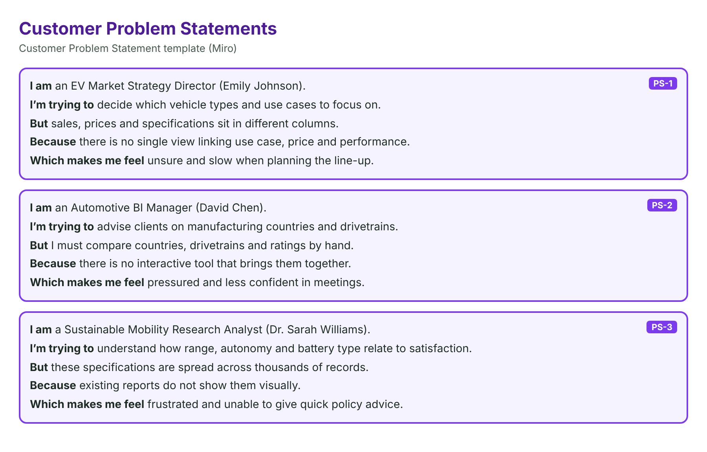
2.2 Empathy Map Canvas
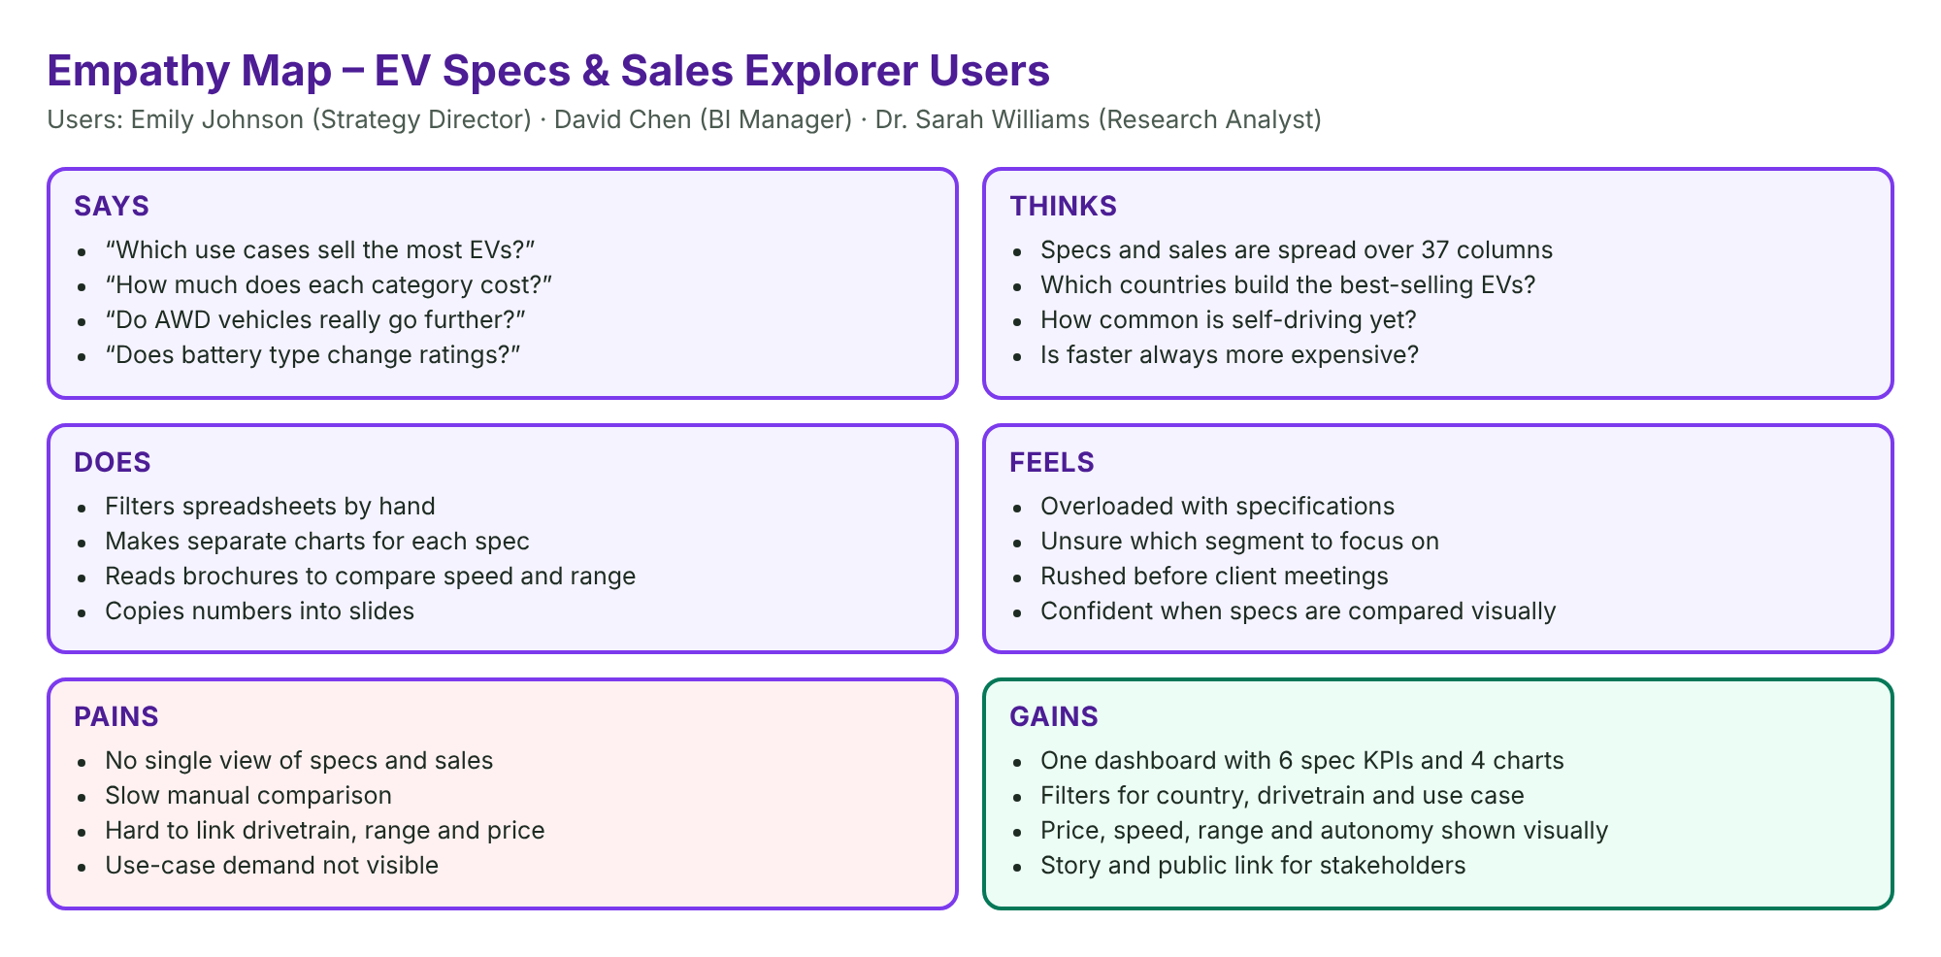
2.3 Brainstorming
Ideas were ranked by importance and feasibility. A specs & sales dashboard with KPIs, use case, price, country and rating views, plus drivetrain, autonomy and performance sheets with a story, were selected; a mobile app was not.
3. REQUIREMENT ANALYSIS
3.1 Customer Journey Map
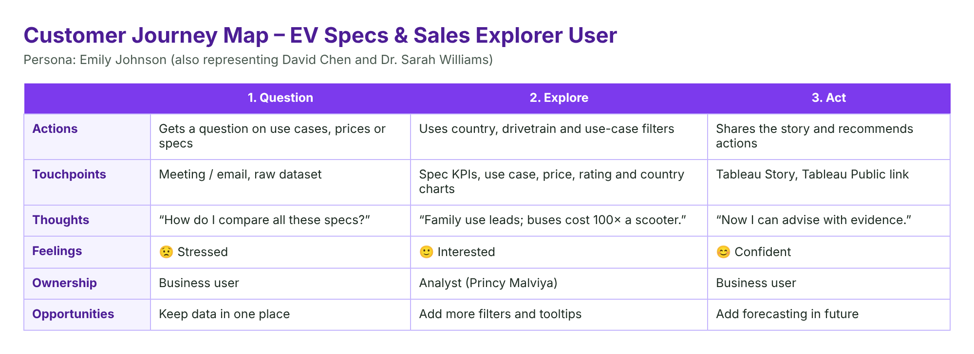
3.2 Solution Requirement
FR | Requirement | Description
FR-1 | Data access | Connect ev_market_clean.csv to Tableau as an extract
FR-2 | Data processing | Cleaned data; 8 calculated fields
FR-3 | Analysis | SUM, AVG and COUNT by use case, category, country, battery type, drivetrain
FR-4 | Outputs | 9 worksheets, dashboard, story
FR-5 | Interaction | Country, drivetrain and use-case filters
FR-6 | Reporting | Tableau Public link

3.3 Data Flow Diagram
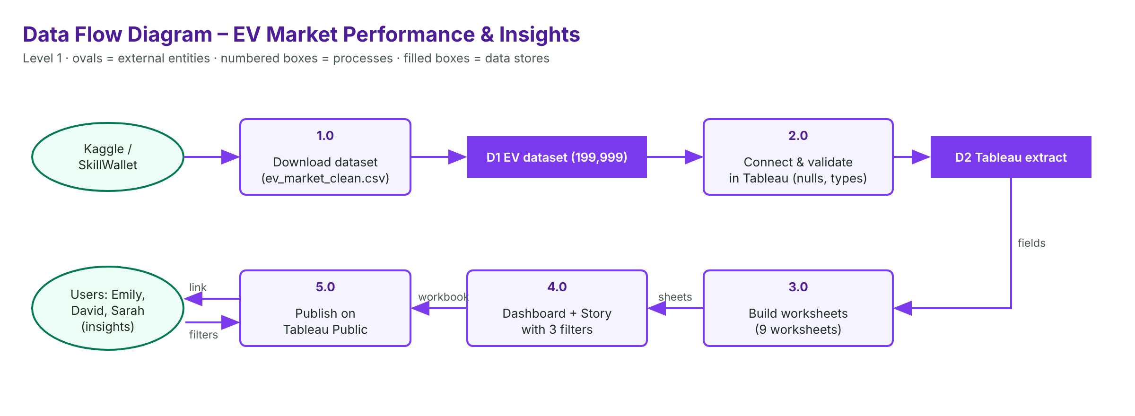
3.4 Technology Stack
Tableau Desktop / Tableau Public for building and publishing; cleaned CSV + Tableau extract for data; 8 Tableau calculated fields; GitHub for files and documentation; Google Drive for the demo video.
4. PROJECT DESIGN
4.1 Problem Solution Fit
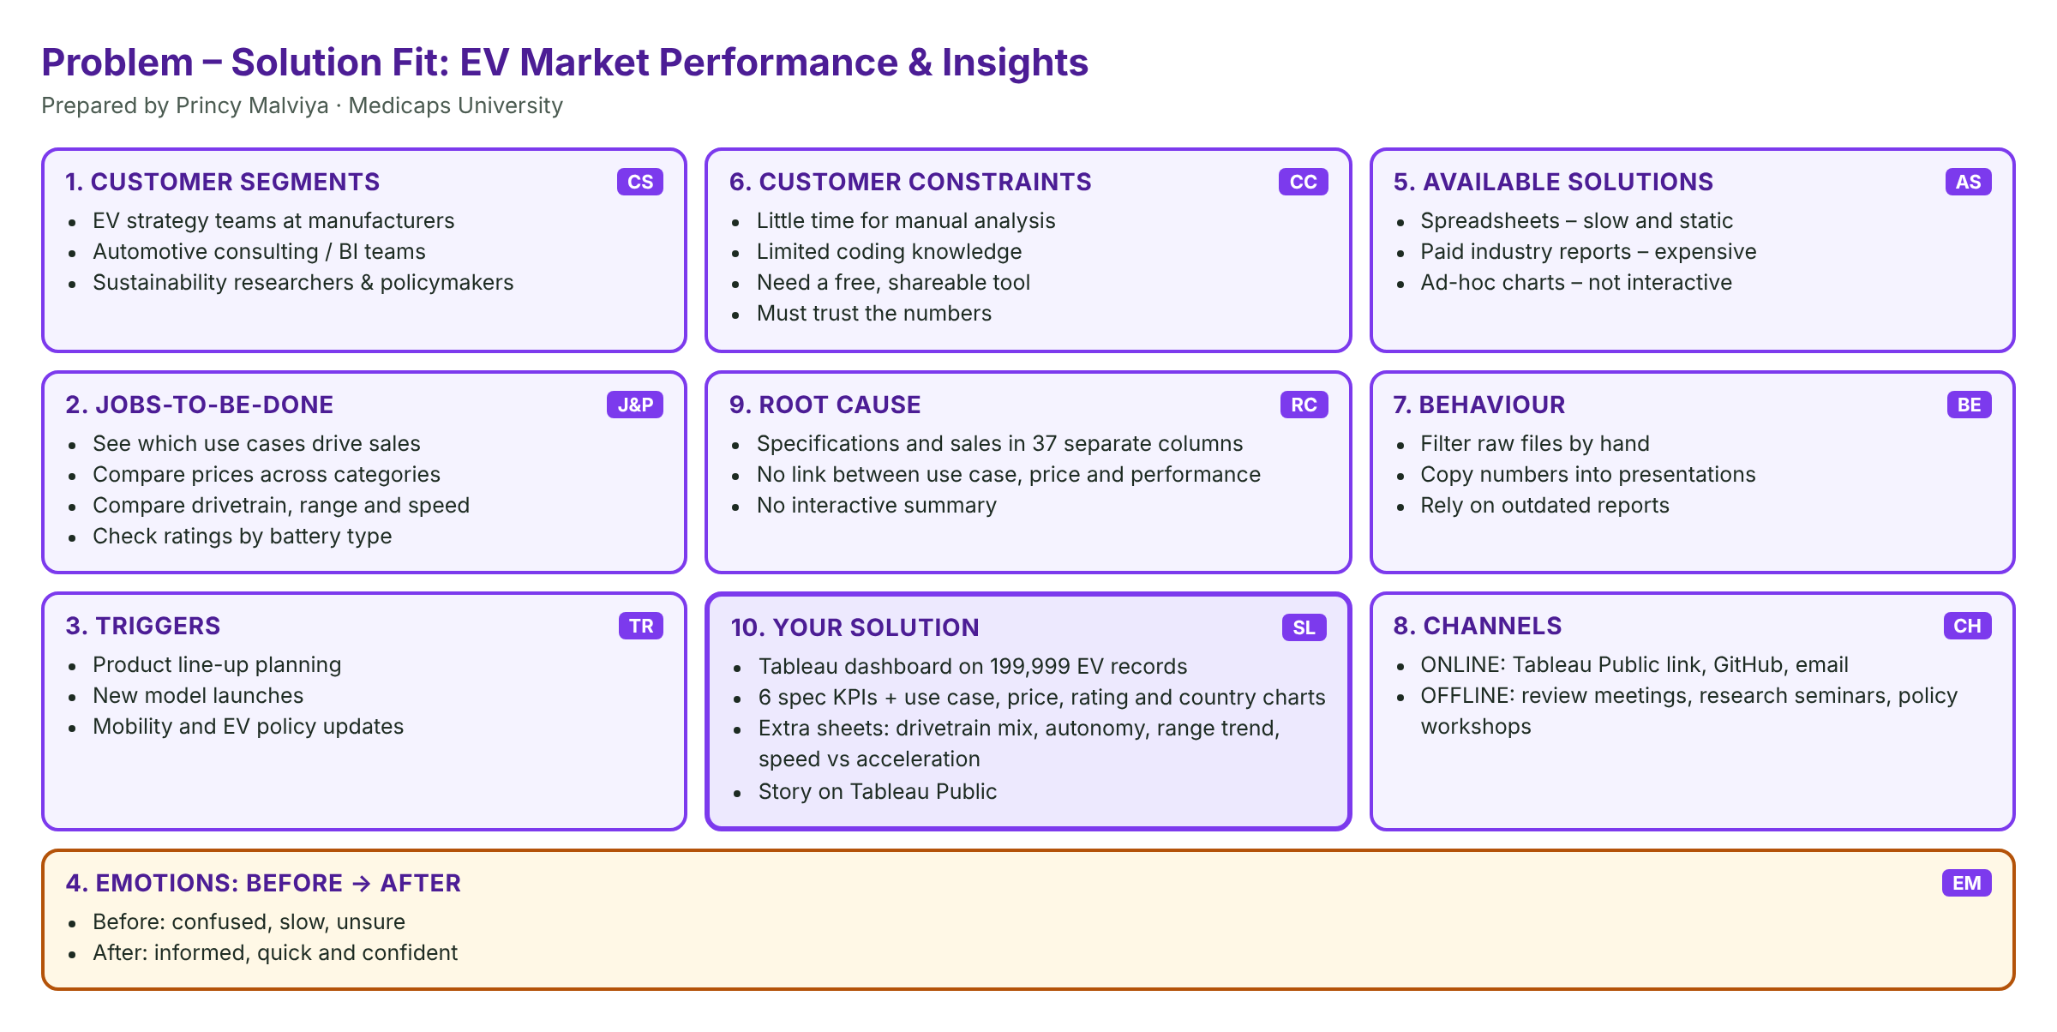
4.2 Proposed Solution
Cleaned data → extract → 8 calculated fields → 9 worksheets → dashboard with 3 shared filters → story → Tableau Public → testing and documentation.
4.3 Solution Architecture

5. PROJECT PLANNING & SCHEDULING
5.1 Project Planning
19 user stories (44 story points) were completed in 4 one-day sprints from 31 October to 3 November 2026; average velocity 11 points per sprint.
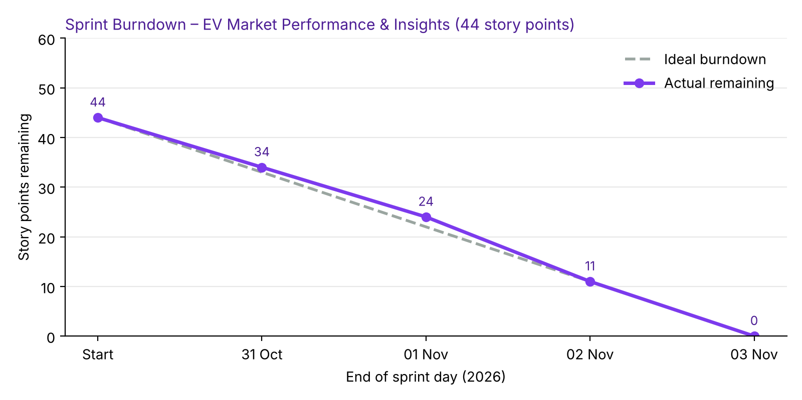
6. FUNCTIONAL AND PERFORMANCE TESTING
6.1 Performance Testing
Parameter | Values
Data Rendered | 199,999 rows × 37 columns + 8 calculated fields
Data Quality | 0 duplicates, 0 missing values
Filters | Manufacturing Country, Drivetrain, Recommended Use Case
Calculations | Total EV Models; Avg Price (USD); Avg Top Speed (km/h); Avg Safety Rating; Avg Resale Value 3yr (%); Avg Warranty (Years); Model Year Label; Autonomy Level
Dashboard | KPIs + 4 charts; 9 worksheets in total
Story | 3 story points

7. RESULTS
7.1 Output Screenshots
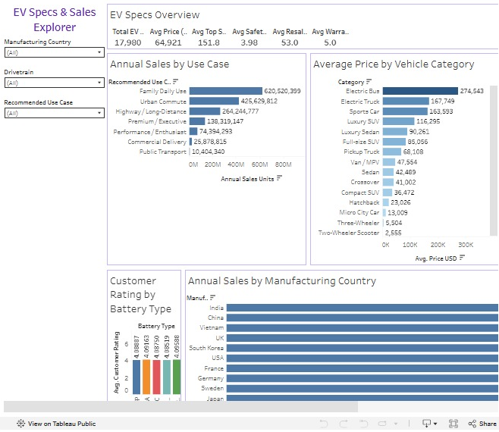
EV Specs & Sales Dashboard
1. EV Specs Overview
Question: What do the headline specifications of the EV market look like? (Scenario 1, 2, 3)
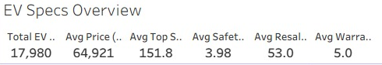
Insight: The dataset covers 17,980 EV models. On average an EV costs 64,921 USD, reaches 151.8 km/h, has a 3.98-star safety rating, keeps 53.0% of its value after 3 years and comes with a 5.0-year warranty.
2. Annual Sales by Use Case
Question: Which use cases drive EV sales? (Scenario 1)
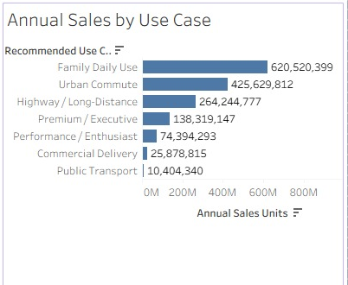
Insight: Family Daily Use is the largest use case with 620.5 M units (about 40% of sales), followed by Urban Commute (425.6 M) and Highway / Long-Distance (264.2 M). Commercial Delivery (25.9 M) and Public Transport (10.4 M) are small niches.
3. Average Price by Vehicle Category
Question: How does the average price change between vehicle categories? (Scenario 1, 2)
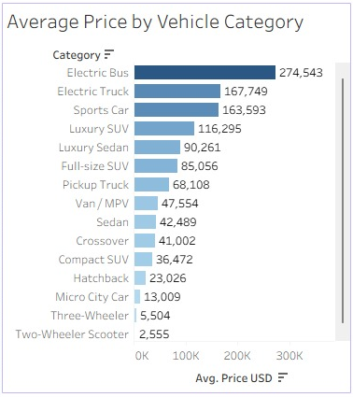
Insight: Electric Buses are the most expensive (274,543 USD), followed by Electric Trucks (167,749 USD) and Sports Cars (163,593 USD). Two-Wheeler Scooters cost only 2,555 USD – about 100 times less than a bus.
4. Drivetrain Mix by Category
Question: Which drivetrains are used in each vehicle category? (Scenario 2)

Insight: Overall the mix is balanced (RWD 69,076, FWD 68,455, AWD 62,468 vehicles). AWD dominates Luxury SUVs, Full-size SUVs, Pickup Trucks and Sports Cars (about 65% each), while FWD and RWD lead in everyday cars, two- and three-wheelers.
5. Customer Rating by Battery Type
Question: Does battery chemistry change customer satisfaction? (Scenario 3)
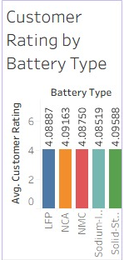
Insight: Ratings are almost identical for every battery type – from 4.085 (Sodium-Ion) to 4.096 (Solid-State) out of 5. Battery chemistry does not change how satisfied customers are.
6. Annual Sales by Manufacturing Country
Question: Which manufacturing countries produce the most-sold EVs? (Scenario 2)
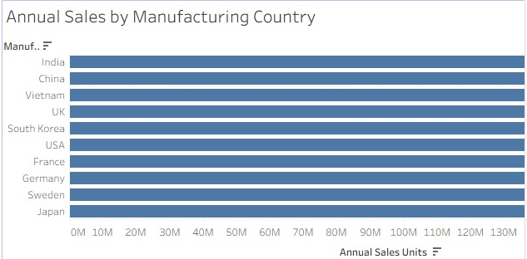
Insight: EVs built in India (160.0 M units) and China (159.4 M) sell the most, followed by Vietnam (158.1 M) and the UK (157.6 M). Japan is lowest (149.1 M). Every country has about 10% of sales, so production is evenly spread.
7. Autonomy Level Distribution
Question: How common are self-driving features? (Scenario 1, 3)

Insight: Level 0 (no automation) is the largest single group at 22.5% of vehicles. Levels 1, 2 and 3 have about 16.5–16.8% each, and Levels 4 and 5 about 13.7% each – so 27.5% of EVs already offer high automation.
8. Average Range Trend by Model Year
Question: Has driving range changed over model years, and does drivetrain matter? (Scenario 1, 3)

Insight: Range stays flat from 2018 to 2026. AWD vehicles travel about 359–364 km on average, around 55 km more than FWD and RWD vehicles (about 305–311 km).
9. Top Speed vs Acceleration
Question: How are acceleration and top speed related across categories? (Scenario 1, 2)

Insight: Faster-accelerating categories also reach higher top speeds (correlation −0.62). Sports Cars lead with 279.9 km/h and 3.2 s to 100 km/h, while Electric Buses reach 85 km/h and need 22.4 s.

Tableau Story
8. ADVANTAGES & DISADVANTAGES
Advantages
• Brings sales, prices and specifications together in one place.
• Three shared filters (country, drivetrain, use case).
• Free and shareable through Tableau Public.
• Story makes findings easy to present.
Disadvantages
• Static data file, no live refresh.
• Four analysis sheets are outside the dashboard.
• No forecasting yet.
9. CONCLUSION
The EV Specs & Sales Explorer shows that Family Daily Use and Urban Commute account for about two-thirds of EV sales, that average prices range from 2,555 USD for scooters to 274,543 USD for buses, that customer ratings are the same (about 4.09) for every battery type, and that EV manufacturing is spread evenly across ten countries led by India and China. The extra sheets show AWD dominating SUVs, pickups and sports cars and giving about 55 km more range, 27.5% of EVs offering Level 4–5 autonomy, and faster-accelerating categories reaching higher top speeds. These insights support Emily’s product planning, David’s client advice and Sarah’s research.
10. FUTURE SCOPE
• Drill-down from category to model.
• Forecast sales by use case.
• Live data with scheduled refresh.
• Price-to-performance scoring.
11. APPENDIX
Item | Link
Dataset | https://www.kaggle.com/datasets/tharishreddy22/electric-vehicle-market-classification-dataset
Dashboard | [Paste Tableau Public dashboard link]
Story | [Paste Tableau Public story link]
GitHub | [Paste GitHub repository link]
Demo video | [Paste Google Drive demo video link]

Data preparation:
• Used the cleaned EV dataset ev_market_clean.csv: 199,999 rows × 37 columns (prepared from the Kaggle / SkillWallet ev_market_train.csv file).
• The file has 0 duplicate rows and 0 missing values (1 duplicate removed and missing values filled with category medians during cleaning).
• Checked data types in Tableau’s Data Source tab; created Model Year Label and Autonomy Level fields so years and autonomy levels work as categories.
• Created a Tableau extract (.hyper) so the dashboard is fast and can be published to Tableau Public.

